Project Design Phase
Solution Architecture
Date | 05 October 2026
Team ID | SWTID-2026-4458
Project Name | Import Data using Transform Maps (Spreadsheet)
Maximum Marks | 4 Marks
Team Size | 5
Team Leader | MONIKA B
Team Members | D KEERTHANA  CHANDHANA S  VEMALARAJU POOJITHA  SUBASRI R
Solution Architecture:
Solution architecture is a complex process – with many sub-processes – that bridges the gap between business problems and technology solutions. Its goals are to:
- Find the best tech solution to solve existing business problems.
- Describe the structure, characteristics, behavior, and other aspects of the software to project stakeholders.
- Define features, development phases, and solution requirements.
- Provide specifications according to which the solution is defined, managed, and delivered.
Solution Architecture Diagram:
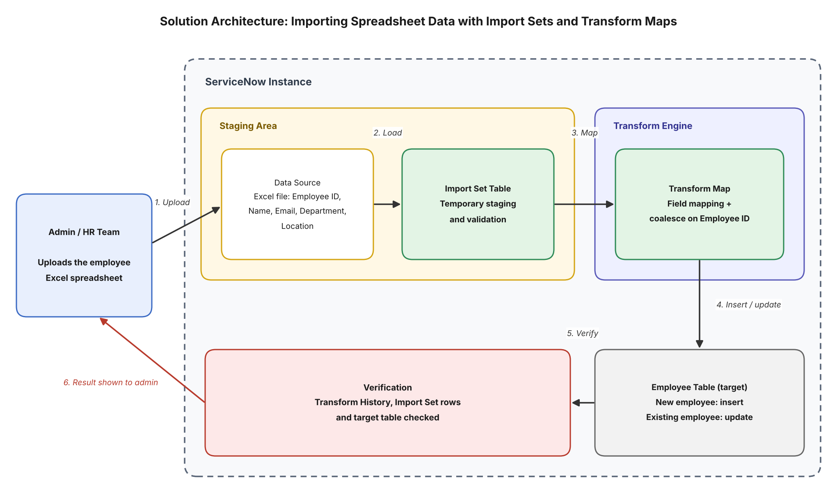
Figure 1: Architecture and data flow of importing spreadsheet data using Import Sets and Transform Maps in ServiceNow
Data flow:
1. The admin or HR team prepares the employee spreadsheet (Employee ID, Name, Email, Department, Location) and uploads it to ServiceNow through a Data Source.
2. The spreadsheet rows are loaded into an Import Set table, which acts as a temporary staging area for processing and validation.
3. The Transform Map maps each source field in the Import Set table to the matching field in the target Employee table, with Employee ID set as the coalesce field.
4. During the transform, existing employees are matched on Employee ID and updated, while new employees are inserted as new records in the Employee table.
5. The admin verifies the result in the Transform History, the Import Set rows and the Employee table to confirm data integrity.
6. The outcome is shown to the admin, who corrects any mapping issues and re-runs the transform if needed.

